Test No.(2) Reinforced Concrete Design (2) 25/11/2024Answer **THREE** Questions OnlyTime: **TWO** Hours **Question 1.**Design a single flight of staircase, of span 3.08 m and height of 1.8 m, supported on beams at both sides cast monolithically with the staircase flight. Imposed load is 5 kN/m2, cover 25 mm, tread 280 mm, riser 160 mm, waist 150 mm, steel reinforcement diameter φ=16 mm, concrete unit weight 24 kN/m3, fcu=25 N/mm2, fy=460 N/mm2. Use 1m width of stair slab in the design to Determine the following: a)Numbers of risers & treads. b)Reinforcement. c)Check deflection. d)Draw section of the flight showing dimensions & reinforcement.

Q2.A ribbed floor, to be constructed using light moulds, is continuous over several equal spans of 5.50 m. For the section at midspan the total depth (h) is 260 mm, distance between centers of ribs is 450 mm, rib width is 130 mm, topping thickness (flange) is 40 mm, total DL is 4 kN/m2, IL 4 kN/m2, fcu=30 N/mm2, fy=420 N/mm2, steel reinforcement diameter 16mm, cover 25mm, moment coefficient is 0.063, shear coefficient is 0.5.

a)Design the slab.

b)Draw plan & section showing dimensions & reinforcement.

**Question 3.** A **braced** column of cross-section 550x350 mm carries at **ultimate** limit state an axial load of 1800 kN, and top end moment of 80 kNm & bottom end moment of 40 kNm. Effective heights Lex=7.5 m, Ley=9.5 m, fcu=30 N/mm2, fy= 460 N/mm2.. Determine the following: a) Classify the column. b)Determine the steel reinforcement by doing at least two trials. c)Draw plan & section of the column showing dimensions & reinforcement.

**Question 4:** The column shown in the figure is to be designed to resist an **ultimate** axial load of 1200 kN plus moments of Mx=90 kNm, My=80 kNm. β=0.55, fcu=30 N/mm2, fy=460 N/mm2. 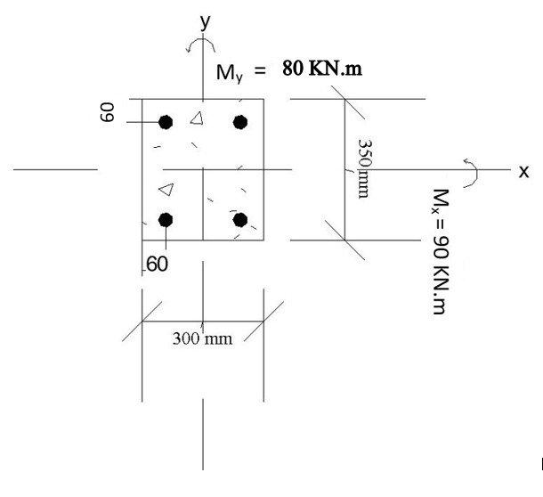

**يجب إرسال الحل عند انتهاء الزمن المحدد الى واتساب د.كمال ساتى 00249901235478**

